2. Spring Rest Hands On

Write a REST service in the spring learn application created earlier, that returns the text "Hello World!!" using Spring Web Framework. Refer details below:  
**Method:** GET  
**URL:** /hello  
**Controller:** com.cognizant.spring-learn.controller.HelloController  
**Method Signature:** public String sayHello()  
**Method Implementation:** return hard coded string "Hello World!!"  
**Sample Request**: http://localhost:8083/hello  
**Sample Response:** Hello World!!   
**IMPORTANT NOTE**: Don't forget to include start and end log in the sayHello() method.  
Try the URL http://localhost:8083/hello in both chrome browser and postman.

**Project Structure:**

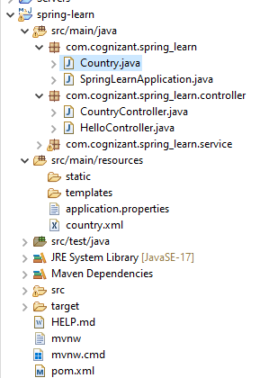







**Code:**

**SpringLearnApplication.java**

**package** com.cognizant.spring_learn;

**import** org.springframework.boot.SpringApplication;

**import** org.springframework.boot.autoconfigure.SpringBootApplication;

@SpringBootApplication

**public** **class** SpringLearnApplication {

**public** **static** **void** main(String[] args) {

SpringApplication.*run*(SpringLearnApplication.**class**, args);

}

}

**HelloController.java**

**package** com.cognizant.spring_learn.controller;

**import** org.slf4j.Logger;

**import** org.slf4j.LoggerFactory;

**import** org.springframework.web.bind.annotation.GetMapping;

**import** org.springframework.web.bind.annotation.RestController;

@RestController

**public** **class** HelloController {

**private** **static** **final** Logger ***LOGGER*** = LoggerFactory.*getLogger*(HelloController.**class**);

@GetMapping("/hello")

**public** String sayHello() {

***LOGGER***.info("START - sayHello()");

String response = "Hello World!!";

***LOGGER***.info("END - sayHello()");

**return** response;

}

}

**application.properties**

spring.application.name=spring-learn

logging.level.com.cognizant.spring_learn=DEBUG

server.port=8083

**pom.xml**  
  
<dependency>

<groupId>org.springframework.boot</groupId>

<artifactId>spring-boot-starter-web</artifactId>

</dependency>

**Output: Postman**

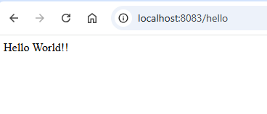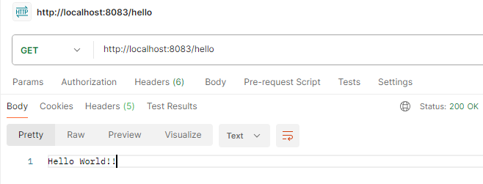

**Chrome**

**Console logs**

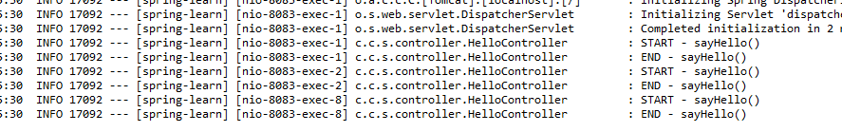

**REST - Country Web Service**   
  
Write a REST service that returns India country details in the earlier created spring learn application.  
  
**URL**: /country  
**Controller**: com.cognizant.spring-learn.controller.CountryController  
**Method Annotation**: @RequestMapping  
**Method Name**: getCountryIndia()  
**Method Implementation**: Load India bean from spring xml configuration and return  
**Sample Request**: http://localhost:8083/country  
**Sample Response**:

{

  "code": "IN",

  "name": "India"

}

**Project Structure:**

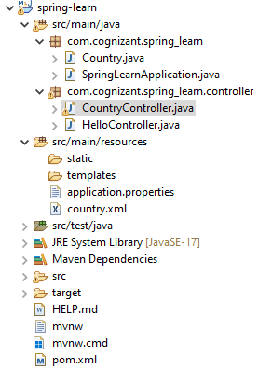

**Code:**

**country.xml**<?xml version=*"1.0"* encoding=*"UTF-8"*?>

<beans xmlns=*"http://www.springframework.org/schema/beans"*

xmlns:xsi=*"http://www.w3.org/2001/XMLSchema-instance"*

xsi:schemaLocation=*"*

*http://www.springframework.org/schema/beans*

*http://www.springframework.org/schema/beans/spring-beans.xsd"*>

<bean id=*"country"* class=*"com.cognizant.spring_learn.Country"*>

<property name=*"code"* value=*"IN"*/>

<property name=*"name"* value=*"India"*/>

</bean>

</beans>

**Country.java**

**package** com.cognizant.spring_learn;

**public** **class** Country {

**private** String code;

**private** String name;

**public** Country() {

System.***out***.println("Inside Country Constructor.");

}

**public** String getCode() {

System.***out***.println("Getting code: " + code);

**return** code;

}

**public** **void** setCode(String code) {

System.***out***.println("Setting code: " + code);

**this**.code = code;

}

**public** String getName() {

System.***out***.println("Getting name: " + name);

**return** name;

}

**public** **void** setName(String name) {

System.***out***.println("Setting name: " + name);

**this**.name = name;

}

@Override

**public** String toString() {

**return** "Country [code=" + code + ", name=" + name + "]";

}

}

**CountryController.java**

package com.cognizant.spring_learn.controller;

import com.cognizant.spring_learn.Country;

import org.slf4j.Logger;

import org.slf4j.LoggerFactory;

import org.springframework.context.ApplicationContext;

import org.springframework.context.support.ClassPathXmlApplicationContext;

import org.springframework.web.bind.annotation.RequestMapping;

import org.springframework.web.bind.annotation.RestController;

@RestController

public class CountryController {

private static final Logger LOGGER = LoggerFactory.getLogger(CountryController.class);

@RequestMapping("/country")

public Country getCountryIndia() {

LOGGER.info("START - getCountryIndia()");

ApplicationContext context = new ClassPathXmlApplicationContext("country.xml");

Country country = context.getBean("country", Country.class);

LOGGER.info("END - getCountryIndia()");

return country;

}

}

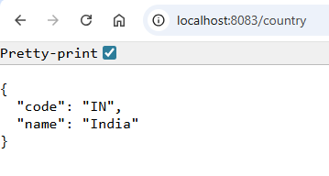**Output:**

**Chrome:**

**Postman:**

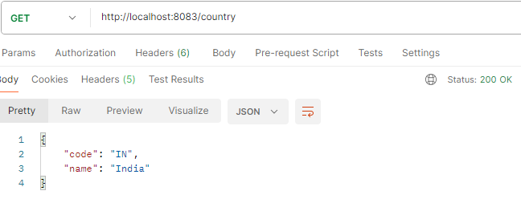

**Console logs:**

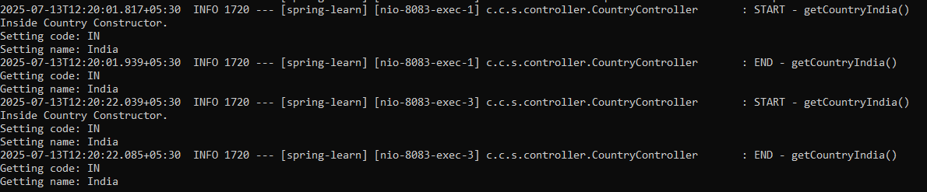

**REST - Get country based on country code**   
  
Write a REST service that returns a specific country based on country code. The country code should be case insensitive.  
  
**Controller**: com.cognizant.spring-learn.controller.CountryController  
**Method Annotation:** @GetMapping("/countries/{code}")  
**Method Name**: getCountry(String code)  
**Method Implemetation**: Invoke countryService.getCountry(code)   
**Service Method:**com.cognizant.spring-learn.service.CountryService.getCountry(String code)  
  
**Service Method Implementation**:

* Get the country code using @PathVariable
* Get country list from country.xml
* Iterate through the country list
* Make a case insensitive matching of country code and return the country.
* Lambda expression can also be used instead of iterating the country list

**Sample Request**: http://localhost:8083/country/in  
  
**Sample Response**:

{

  "code": "IN",

  "name": "India"

}

**Project Structure:**

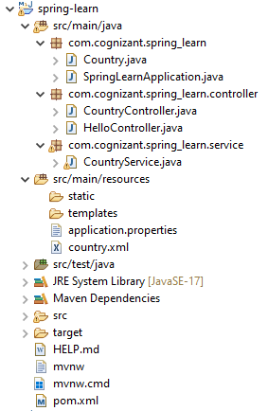

**Country.xml**

<?xml version=*"1.0"* encoding=*"UTF-8"*?>

<beans xmlns=*"http://www.springframework.org/schema/beans"*

xmlns:xsi=*"http://www.w3.org/2001/XMLSchema-instance"*

xsi:schemaLocation=*"*

*http://www.springframework.org/schema/beans*

*http://www.springframework.org/schema/beans/spring-beans.xsd"*>

<bean id=*"country"* class=*"com.cognizant.spring_learn.Country"*>

<property name=*"code"* value=*"IN"*/>

<property name=*"name"* value=*"India"*/>

</bean>

<bean id=*"countryList"* class=*"java.util.ArrayList"*>

<constructor-arg>

<list>

<bean class=*"com.cognizant.spring_learn.Country"*>

<property name=*"code"* value=*"IN"*/>

<property name=*"name"* value=*"India"*/>

</bean>

<bean class=*"com.cognizant.spring_learn.Country"*>

<property name=*"code"* value=*"US"*/>

<property name=*"name"* value=*"United States"*/>

</bean>

<bean class=*"com.cognizant.spring_learn.Country"*>

<property name=*"code"* value=*"JP"*/>

<property name=*"name"* value=*"Japan"*/>

</bean>

<bean class=*"com.cognizant.spring_learn.Country"*>

<property name=*"code"* value=*"DE"*/>

<property name=*"name"* value=*"Germany"*/>

</bean>

</list>

</constructor-arg>

</bean>

</beans>

**CountryService.java**

**package** com.cognizant.spring_learn.service;

**import** com.cognizant.spring_learn.Country;

**import** org.springframework.context.ApplicationContext;

**import** org.springframework.context.support.ClassPathXmlApplicationContext;

**import** org.springframework.stereotype.Service;

**import** java.util.List;

@Service

**public** **class** CountryService {

**public** Country getCountry(String code) {

ApplicationContext context = **new** ClassPathXmlApplicationContext("country.xml");

List<Country> countryList = context.getBean("countryList", List.**class**);

**return** countryList.stream()

.filter(c -> c.getCode().equalsIgnoreCase(code))

.findFirst()

.orElse(**null**); // or throw custom exception if not found

}

}

**CountryController.java**

**package** com.cognizant.spring_learn.controller;

**import** com.cognizant.spring_learn.Country;

**import** com.cognizant.spring_learn.service.CountryService;

**import** org.slf4j.Logger;

**import** org.slf4j.LoggerFactory;

**import** org.springframework.beans.factory.annotation.Autowired;

**import** org.springframework.web.bind.annotation.*;

@RestController

**public** **class** CountryController {

**private** **static** **final** Logger ***LOGGER*** = LoggerFactory.*getLogger*(CountryController.**class**);

@Autowired

**private** CountryService countryService;

@GetMapping("/country/{code}")

**public** Country getCountry(@PathVariable String code) {

***LOGGER***.info("START - getCountry({})", code);

Country result = countryService.getCountry(code);

***LOGGER***.info("END - getCountry");

**return** result;

}

}

Output:

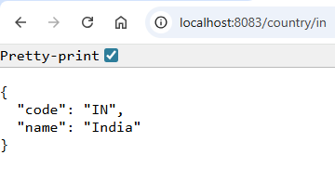Chrome:

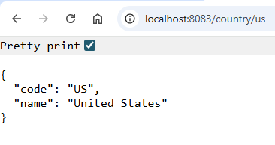

**Postman:**

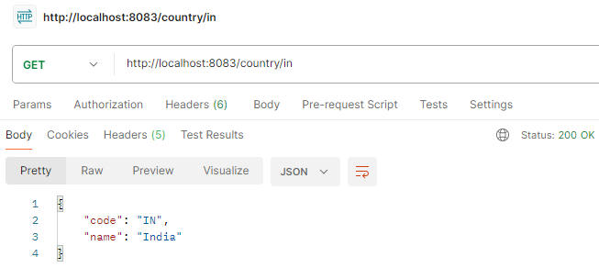

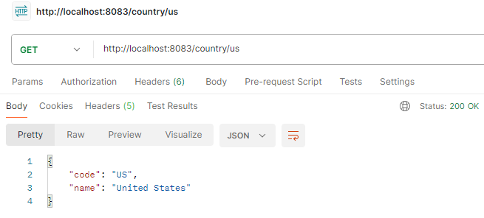

**Console logs:**